PROJECT SYNOPSIS

1. Project Title -
Android Based Smart Parking System (Smart Parking Slot Detection And Reservation System)

2. Student Details -
Name: Rohit Yadav
Programme: M.Sc. Computer Science & Information Technology
Department: Computer Science and Information Technology
Institution: JAIN University
Academic Year: 2025–2026
Guide: Dr. Haripriya V

3. Abstract –
Parking congestion is a growing problem in urban and semi-urban environments due to the rapid increase in vehicle ownership and limited infrastructure expansion. Traditional parking management systems rely heavily on manual supervision, leading to inefficiencies such as time wastage, improper slot allocation, and user inconvenience. Although smart parking systems have been introduced to address these issues, most existing solutions depend on Internet of Things (IoT) sensors, RFID modules, or camera-based monitoring systems. These hardware-dependent solutions significantly increase implementation cost, maintenance complexity, and scalability challenges, especially in small and private parking environments.
This project proposes a software-based Smart Parking Management System implemented as an Android mobile application integrated with a centralized database. Unlike IoT-driven systems, the proposed system relies on rule-based dynamic reservation logic and real-time database synchronization to manage parking slot availability. A synthetic, system-generated dataset consisting of parking locations, slots, user records, and reservation logs is used for simulation and evaluation.
The research focuses on evaluating feasibility, scalability, data consistency, and response efficiency of a software-only parking solution. The expected outcome is a cost-effective, easily deployable, and scalable parking management system that can function efficiently without hardware infrastructure. The system is particularly suitable for educational institutions, residential complexes, commercial establishments, and private parking facilities.

4. Introduction & Background –
Parking management has become a significant challenge due to increasing vehicle density in urban and semi-urban regions. Traditional parking systems rely on manual supervision, which often leads to inefficiency, mismanagement, and time wastage. Although smart parking systems have emerged, most of them are built on IoT-based sensor networks and hardware infrastructure.
While IoT-based systems offer automation, they introduce high installation cost, ongoing maintenance requirements, and scalability issues. Many small-scale or private parking facilities cannot afford such infrastructure. Therefore, there is a strong need for a cost-effective and easily deployable software-oriented parking management system.
4.1 Context of the Problem –
Rapid urbanization and the exponential growth in vehicle ownership have created significant challenges in parking management across cities and semi-urban regions. The demand for parking spaces has increased substantially, while infrastructure development has not kept pace. As a result, drivers often spend considerable time searching for available parking slots, leading to congestion, increased fuel consumption, environmental pollution, and user frustration.
Traditional parking systems largely rely on manual supervision or static allocation mechanisms. These systems lack real-time visibility into slot availability and do not provide centralized coordination. Consequently, parking resources are often underutilized or mismanaged. Although smart parking solutions have been introduced to address these inefficiencies, most existing systems depend heavily on IoT sensors, RFID devices, or camera-based monitoring systems, which significantly increase system complexity and cost.
4.2 Importance of the Domain –
Parking management is a critical component of urban mobility and smart city development. Efficient parking systems contribute to:
- Reduction in traffic congestion
- Improved fuel efficiency
- Decreased environmental impact
- Enhanced user convenience
- Better utilization of infrastructure
With the growing adoption of mobile technologies and digital services, there is a strong opportunity to leverage software-based systems for improving parking operations. Developing cost-effective and scalable parking management solutions is essential for institutions, residential complexes, commercial establishments, and public facilities that may not have the financial capacity to deploy hardware-intensive IoT systems.
4.3 Real-World Relevance -
In real-world scenarios, many small-scale parking providers—such as educational institutions, apartment complexes, shopping malls, and private parking operators—continue to use manual or semi-automated parking management methods. These systems lack real-time updates and centralized tracking, leading to inefficient space utilization and user dissatisfaction.
IoT-based parking systems, while technologically advanced, are often impractical for such environments due to high installation costs, maintenance requirements, and technical expertise needed for operation. A software-based parking management system that operates through a mobile application and centralized database can provide real-time slot updates and reservation functionality without requiring physical sensors. This makes the proposed system highly applicable in cost-sensitive and infrastructure-limited environments.
4.4 Motivation for the Study –
The primary motivation behind this study is to address the limitations of hardware-dependent smart parking systems and explore a feasible software-driven alternative. While reviewing existing literature, it was observed that most research emphasizes sensor-based detection and IoT integration, with limited attention given to rule-based, database-driven parking reservation systems.
There is a clear need for a simplified yet effective parking management solution that:
- Eliminates dependency on hardware infrastructure
- Reduces implementation and maintenance costs
- Ensures real-time dynamic updates
- Remains scalable and easy to deploy
This research is motivated by the objective of designing and evaluating a software-only smart parking management system that can deliver practical benefits while maintaining affordability and scalability. By focusing on centralized data management and rule-based dynamic reservation logic, the study aims to demonstrate that effective parking management can be achieved without relying on IoT sensors or machine learning models.
5. Problem Identification –
Despite the availability of smart parking systems and IoT-enabled monitoring solutions, there exist significant challenges such as high infrastructure cost, dependency on hardware components, complex maintenance requirements, and limited scalability in small-scale environments. These challenges lead to restricted adoption of smart parking technologies, continued reliance on inefficient manual parking management, and underutilization of available parking resources, affecting institutions, private parking providers, and end users.
Most existing solutions prioritize sensor-based vehicle detection rather than centralized, software-driven reservation management. As a result, parking facilities that lack the financial or technical capacity to deploy IoT infrastructure are unable to benefit from smart parking advancements. Furthermore, hardware malfunctions, network failures, and calibration issues can compromise system reliability.
Hence, there is a need for a software-based, cost-effective, and easily deployable parking management system that can dynamically manage parking slot availability and reservations using a centralized database and rule-based logic, without relying on IoT hardware infrastructure.

6. Literature Review Summary-
Author(s) | Year | Method / Technique | Findings | Limitations
Yanfeng Geng & Christos G. Cassandras | 2012 | Mixed Integer Linear Programming (MILP) for dynamic reservation | Automated allocation reduces search time and improves efficiency | Difficult real-world implementation; infrastructure dependency
Suhas Mathur et al. (ParkNet) | 2010 | Drive-by sensing using ultrasonic sensors + GPS | Achieved ~95% detection accuracy | GPS inaccuracies in dense urban areas
Amin Kianpisheh and others. | 2012 | IoT-based E-parking using sensors and automated billing | Improved monitoring and automation | High hardware density and maintenance cost
S. Idris and others. | 2019 | IoT-based smart parking using embedded sensors | Accurate real-time slot monitoring | Power and network dependency
Anagha R and others. | 2019 | Survey comparing IoT and CNN-based systems | ML-based systems provide higher detection accuracy | Image quality dependency and computational complexity
Ketaki Bhoyar and others. | 2018 | IoT + Android-based reservation system | User-friendly reservation interface | Hardware prototype limited in scalability
Tawfeeq Shawly and others. | 2022 | Fuzzy logic-based intelligent transportation system | Improved decision-making in allocation | Wireless technology limitations
Maddela Bhargavi and others. | 2025 | Systematic review of 124 smart parking studies | Shift toward AI, sensor fusion, blockchain | Security vulnerabilities and environmental interference

1. Yanfeng Geng & Christos G. Cassandras (2012) – Dynamic Parking Reservation Using Mixed Integer Linear Programming
Objective:
To develop an optimized dynamic parking reservation system to reduce vehicle search time and improve allocation efficiency.
Methods:
The study applied Mixed Integer Linear Programming (MILP) to model parking space allocation and optimize reservation scheduling under dynamic conditions.
Results:
The proposed optimization framework demonstrated reduced search time and improved utilization of available parking spaces.
Conclusion:
Although effective in theory, the model faced challenges in real-world deployment due to infrastructure dependency and system complexity.

2. Suhas Mathur et al. (2010) – ParkNet: Drive-by Sensing for Urban Parking
Objective:
To design a mobile sensing system capable of detecting vacant parking spaces using drive-by vehicles.
Methods:
The system integrated ultrasonic sensors and GPS modules mounted on vehicles to detect and map available parking slots.
Results:
ParkNet achieved approximately 95% detection accuracy under controlled urban conditions.
Conclusion:
While promising, the approach suffered from GPS inaccuracies and signal interference in dense metropolitan areas.

3. Amin Kianpisheh et al. (2012) – IoT-Based E-Parking System
Objective:
To develop an IoT-enabled electronic parking system for real-time slot monitoring and automated billing.
Methods:
The system utilized embedded sensors connected to a centralized server for monitoring slot occupancy and managing payments.
Results:
The framework improved monitoring efficiency and reduced manual supervision requirements.
Conclusion:
High hardware density and maintenance costs limited scalability and widespread implementation.

4. S. Idris et al. (2019) – Smart Parking System Using IoT
Objective:
To implement an IoT-based smart parking solution for real-time monitoring of slot availability.
Methods:
The system incorporated embedded sensors and wireless communication modules integrated with a cloud platform.
Results:
Accurate real-time slot detection and status updates were achieved.
Conclusion:
The system required continuous power supply and network connectivity, increasing operational dependency.

5. Anagha R et al. (2019) – Comparative Survey of IoT and CNN-Based Parking Systems
Objective:
To compare IoT-based parking systems with machine learning-based image detection systems.
Methods:
A comprehensive survey and analytical comparison of existing smart parking models were conducted.
Results:
Machine learning-based approaches demonstrated higher detection accuracy compared to traditional sensor-based systems.
Conclusion:
Performance depended heavily on image quality and computational resources.

6. Ketaki Bhoyar et al. (2018) – IoT and Android-Based Smart Parking System
Objective:
To develop a user-friendly Android application integrated with IoT hardware for parking reservation.
Methods:
The system combined embedded hardware modules with a mobile application for booking and monitoring.
Results:
The reservation interface improved usability and user engagement.
Conclusion:
The hardware prototype showed limitations in scalability for large urban deployments.

7. Tawfeeq Shawly et al. (2022) – Fuzzy Logic-Based Intelligent Transportation System
Objective:
To enhance parking allocation decisions using fuzzy logic techniques.
Methods:
Fuzzy inference mechanisms were implemented to manage uncertainty in slot allocation.
Results:
Improved decision-making and adaptive allocation were observed.
Conclusion:
Performance was constrained by wireless communication reliability.

8. Maddela Bhargavi et al. (2025) – Systematic Review of Smart Parking Systems
Objective:
To analyze and summarize recent developments in smart parking technologies.
Methods:
A systematic review of 124 research studies covering IoT, AI, blockchain, and sensor fusion technologies was conducted.
Results:
The study identified a shift toward AI-driven and hybrid parking management systems.
Conclusion:
Security vulnerabilities, environmental interference, and scalability challenges remain unresolved.

7. Research Gap –
From the literature review, it is observed that:
- Most existing methods rely heavily on IoT sensors, RFID modules, embedded hardware, or camera-based detection systems for real-time parking slot monitoring and allocation.
- There is limited focus on purely software-based, centralized database-driven parking reservation systems that operate without hardware infrastructure.
- Current approaches fail to address cost-effective deployment, scalability in small-scale environments, and simplified maintenance for institutions and private parking providers that cannot afford sensor-based systems.
Additionally, a majority of research emphasizes vehicle detection accuracy rather than dynamic reservation logic, centralized data consistency, and rule-based conflict handling mechanisms. Hardware-dependent systems also introduce challenges such as power consumption, network instability, sensor calibration issues, and increased operational costs.
Hence, there is a research gap in the design and evaluation of a scalable, software-only, Android-based smart parking management framework that eliminates IoT dependency while maintaining real-time reservation functionality and centralized control, which this project aims to address.

8 . Research Questions –
- How can parking slot management be improved using a centralized, software-based Android application without relying on IoT infrastructure?

- What is the impact of a rule-based dynamic reservation mechanism on data consistency and conflict prevention in real-time booking scenarios?
- Can a software-only smart parking management system provide a cost-effective and scalable alternative to existing IoT-based parking solutions?

- How effectively can centralized database synchronization handle concurrent user reservation requests without double booking or data inconsistency?

9. Problem Statement –

The problem addressed in this project is to design and develop a software-based Android Smart Parking Management System that can efficiently manage real-time parking slot availability and reservation operations using a centralized database architecture, while overcoming the cost, maintenance complexity, scalability limitations, and hardware dependency associated with existing IoT-based smart parking systems.

10. Objectives of the Study –

General Objective – To design and develop a software-based Android Smart Parking Management System for efficient and dynamic parking slot management without relying on IoT infrastructure.

- Specific Objectives –

- To study existing techniques for smart parking management, particularly IoT-based and hardware-dependent systems, and analyze their limitations.
- To design a centralized, rule-based reservation framework for dynamic parking slot allocation and conflict prevention.
- To implement the proposed approach using Android (Kotlin) and a centralized database system for real-time synchronization.
- To evaluate the performance of the system based on response time, data consistency, reservation success rate, and scalability under concurrent user scenarios.
11. Proposed Methodology –
The proposed research follows a system design and experimental evaluation approach. The objective is to develop a software-based Smart Parking Management System implemented as an Android application integrated with a centralized real-time database. The system eliminates hardware dependency by using rule-based logic for dynamic reservation handling and centralized synchronization.
11.1 System Architecture –
The proposed system follows a three-layer architecture:
- Presentation Layer (User Interface) –
- Android mobile application
- Allows users to:-
- Search parking locations
- View available slots
- Reserve parking spaces
- Receive booking confirmation
- Admin interface allows: -
- Adding parking locations
- Managing slot information
- Monitoring reservation logs
- Business Logic Layer (Reservation Engine) –
- This layer handles:-
- Slot availability validation
- Conflict detection
- Reservation confirmation logic
- Real-time update mechanisms
- Prevention of double booking
- A rule-based allocation mechanism is implemented where:-
- A slot can be reserved only if status = “Available”
- Upon reservation, status is immediately updated to “Booked”
- Database transaction ensures consistency
- Data Layer (Centralized Database) –
The database stores:
- Parking locations
- Slot details
- User information
- Reservation records
- Booking timestamps
Real-time synchronization ensures that updates made by one user are immediately reflected for others.
11.2 Algorithm –

Rule-Based Reservation Algorithm -
Step 1: User selects parking location
Step 2: System retrieves available slots
Step 3: Check if selected slot status = Available
Step 4: Lock slot temporarily
Step 5: Confirm reservation
Step 6: Update slot status to Booked
Step 7: Store reservation log

This ensures:
- No double booking
- Atomic transaction handling
- Real-time data consistency

11.3 Tools -
- Programming Language: Kotlin
- Platform: Android
- IDE: Android Studio
- Database: Firebase Realtime Database / Firestore
- Version Control: GitHub

11.4 Data Sources -
The system uses a synthetic, system-generated dataset consisting of:-
- Parking location records
- Slot allocation data
- User accounts
- Reservation logs
The data is generated through administrative input and simulated user interactions for evaluation purposes. No external datasets or IoT sensor data are used.

11.5 System Workflow -

Input:-
- User search request
- Slot selection
- Reservation request
- Admin parking data entry

Processing:-
- Slot availability validation
- Conflict detection logic
- Database transaction processing
- Real-time synchronization

Output:-
- Display of available parking slots
- Reservation confirmation message
- Updated slot status
- Reservation history record

11.6 Evaluation Approach -
The system will be evaluated under simulated multi-user conditions based on:
- Response Time
- Reservation Success Rate
- Data Consistency
- Conflict Handling Efficiency
- Scalability under concurrent requests

12. Tools & Technologies -
Category | Details
Programming Language | Java/Kotlin
Framework / SDK | Android SDK, Jetpack Components
Database | Firebase Realtime Database / Cloud Firestore
Authentication Service | Firebase Authentication
IDE | Android Studio
Version Control | Git / GitHub
Platform | Android OS
Development Environment | Windows

13. Expected Outcomes -
- The proposed system is expected to develop a fully functional Android-based Smart Parking Management prototype capable of managing real-time parking slot reservations without IoT infrastructure.
- The proposed system is expected to substantially reduce double reservation conflicts compared to manual systems, and the exact percentage improvement will be determined through experimental evaluation.
- The system is expected to improve reservation confirmation speed by providing booking validation within few seconds under normal operating conditions.
- The proposed approach is expected to enhance data consistency and reliability through centralized database synchronization and rule-based validation mechanisms.
- The study is expected to validate that a software-only smart parking framework can serve as a cost-effective and scalable alternative to hardware-dependent IoT systems.
- The research is expected to result in a structured academic paper and final project report documenting the methodology, implementation, and evaluation findings.

14. Scope of the Project -
- This project focuses on the design and development of a software-based Android Smart Parking Management System that enables users to search, view, and reserve parking slots through a centralized database system. The project covers dynamic slot management, rule-based reservation validation, real-time synchronization, user authentication, and administrative control for managing parking data.
- The study includes system architecture design, implementation using Android and Firebase technologies, and performance evaluation based on response time, booking efficiency, data consistency, and scalability under simulated multi-user scenarios.
- It does not include IoT sensor integration, hardware-based vehicle detection, camera-based monitoring systems, or machine learning-based predictive models due to cost, infrastructure, and time constraints. The project also does not involve real-world large-scale deployment testing, as evaluation is conducted in a controlled and simulated environment.

15. Limitations –
The proposed study has the following limitations:-
- Conceptual Stage Limitation:-
The work currently presents a proposed architectural framework and system design. Full-scale implementation and empirical performance validation are planned for subsequent phases.

- Data Dependency:-
The proposed framework assumes structured parking data and centralized database availability. Real-time integration with heterogeneous external infrastructure is not addressed at the proposal stage.
- Infrastructure Assumptions:-
The system design assumes stable network connectivity for centralized synchronization. Variations in connectivity conditions have not been empirically analyzed within the current scope.

16. Ethical Considerations -
The proposed system adheres to ethical principles related to data privacy, user consent, and responsible technology use.
- Data Privacy:-
The system is designed to collect only essential user information required for authentication and reservation management. Personal data such as user credentials and booking records will be securely stored using authenticated database access mechanisms. No unnecessary personal or sensitive data will be collected.

- User Consent:-
Users will provide explicit consent during registration before submitting personal information. The system will clearly inform users about the purpose of data collection, which is limited to parking reservation management.
- Responsible Use of Technology:-
The proposed framework is intended solely for lawful parking management purposes. The system will not support surveillance, tracking beyond reservation needs, or unauthorized data sharing. Access to administrative controls will be restricted to authorized personnel only.
The proposed study ensures that ethical considerations are integrated into the system design to maintain transparency, security, and responsible digital practices.

17. Work Plan & Timeline-
Phase | Activity | Duration
Phase 1 | Problem identification, literature review, and research gap analysis | Week 1
Phase 2 | System architecture design, framework modeling, and methodology formulation | Week 2–3
Phase 3 | Prototype development (Android application and database integration) | Week 4–6
Phase 4 | System testing, validation, and performance evaluation | Week 7
Phase 5 | Documentation, research paper preparation, and final report submission | Week 8
18. References (IEEE Format) -
[1] S. Mathur, T. Jin, N. Kasturirangan, et al., “ParkNet: Drive-by Sensing of Road-Side Parking Statistics,” in Proceedings of the 8th International Conference on Mobile Systems, Applications, and Services (MobiSys), 2010.
[2] Y. Geng and C. G. Cassandras, “A New ‘Smart Parking’ System Infrastructure and Implementation,” Procedia - Social and Behavioral Sciences, 2012.
[3] A. Kianpisheh, N. Mustaffa, P. Limtrairut, and P. Keikhosrokiani, “An IoT-based E-Parking System for Smart Cities,” in International Conference on Advances in Computer Science and Engineering, 2012.
[4] J. K. Suhr and H. G. Jung, “Full-automatic Recognition of Various Parking Slot Markings Using a Hierarchical Tree Structure,” Optical Engineering (SPIE), 2013.
[5] S. Idris, Y. Leng, and E. Tamil, “Smart Parking System Using IoT,” 2019.
[6] A. R., A. S., S. B. S., and S. B. S., “An Interactive Approach for Smart Parking System,” International Journal of Computer Trends and Technology, vol. 67, no. 11, 2019.
[7] T. Shawly, A. A. Alsheikhy, and Y. F. S., “Smart Parking System,” International Journal of Scientific Research in Computer Science, 2022.
[8] G. M., K. M. S., and P. Manjunath, “IoT Based Smart Car Parking System,” International Journal of Transportation Engineering and Technology, 2024.
[9] A. Soni, A. Atre, H. Raikwar, et al., “Smart Parking System,” International Journal of Creative Research Thoughts, 2024.
[10] M. Bhargavi, M. V., P. J. N., et al., “Smart Parking Systems: A Comprehensive Review of Current Trends and Future Directions,” Green Energy and Intelligent Transportation, 2025.
[11] S. S. Channamallu, S. Kermanshachi, et al., “A Review of IoT Based Smart Parking Systems: A Comprehensive Study,” International Journal of Innovative Research in Technology, 2026.

19. Source Code / Implementation
The Smart Parking Management System is implemented as an Android application using Kotlin and Firebase. The following code snippets represent key modules of the system.

1. User Authentication (Firebase):-
// Initialize Firebase Authentication instance
val auth = FirebaseAuth.getInstance()

// Function to handle user login
fun loginUser(email: String, password: String) {

// Check if input fields are not empty
if (email.isNotEmpty() && password.isNotEmpty()) {

// Sign in user using Firebase Authentication
auth.signInWithEmailAndPassword(email, password)
.addOnCompleteListener { task ->
if (task.isSuccessful) {
// Login successful - user can proceed to dashboard
} else {
// Login failed - show error message
}
}
}
2. Parking Slot Booking Module (Firestore):-
// Initialize Firestore database instance
val db = FirebaseFirestore.getInstance()

// Function to book a parking slot
fun bookSlot(slotId: String) {

// Reference to selected parking slot document
val slotRef = db.collection("parking_slots").document(slotId)

// Run transaction to ensure safe booking
db.runTransaction { transaction ->

// Get current slot data
val snapshot = transaction.get(slotRef)
val status = snapshot.getString("status")

// Check if slot is available
if (status == "Available") {

// Update slot status to booked
transaction.update(slotRef, "status", "Booked")

} else {
// Throw error if already booked
throw Exception("Slot already booked")
}
}
}

3. Google Maps API Integration:-
// Declare Google Map variable
lateinit var googleMap: GoogleMap

// Called when map is ready to use
override fun onMapReady(map: GoogleMap) {

googleMap = map

// Define parking location coordinates (Example: Bangalore)
val parkingLocation = LatLng(12.9716, 77.5946)

// Add marker on map for parking location
googleMap.addMarker(
MarkerOptions()
.position(parkingLocation)
.title("Parking Location")
)

// Move camera to the parking location with zoom level
googleMap.moveCamera(
CameraUpdateFactory.newLatLngZoom(parkingLocation, 15f)
)
}
4. Conflict Booking Prevention Mechanism:-
// Initialize Firestore instance
val db = FirebaseFirestore.getInstance()

// Function to reserve slot using real-time listener
fun reserveSlot(slotId: String) {

val slotRef = db.collection("parking_slots").document(slotId)

// Add snapshot listener for real-time updates
slotRef.addSnapshotListener { snapshot, error ->

if (error != null) {
// Handle error
return@addSnapshotListener
}

if (snapshot != null && snapshot.exists()) {

// Get current booking status
val isBooked = snapshot.getBoolean("isBooked") ?: false

// Check if slot is available
if (!isBooked) {

// Update slot status to booked
slotRef.update("isBooked", true)
.addOnSuccessListener {
// Booking successful
}
.addOnFailureListener {
// Booking failed
}

} else {
// Prevent booking if already reserved
// Show message: Slot already booked
}
}
}
}

5. Parking Slot Activity (Display Slots):-
// Initialize Firestore instance
val db = FirebaseFirestore.getInstance()

// Function to load parking slots from database
fun loadSlots() {

db.collection("parking_slots")
.get()
.addOnSuccessListener { result ->

// Loop through all slot documents
for (document in result) {

// Retrieve slot details
val slotNumber = document.getString("slotNumber")
val status = document.getString("status")

// Display slot in UI (RecyclerView/List)
}
}
}
}

20. Test Results / Output Screenshots
The following screenshots demonstrate the successful implementation and working of the Smart Parking Management System Android application.
1. User Login Screen – Displays the login interface for registered users to securely access the application using their credentials.
2. User Registration Screen – Allows new users to create an account by providing necessary details using Firebase Authentication.
3. User Dashboard Screen – Provides the main interface for users to navigate through different features such as parking search and bookings.
4. User Parking Finding Screen – Enables users to search for available parking locations within the application.
5. Slot Details Screen (While Searching) – Displays real-time availability and details of parking slots during the search process.
6. Parking Slot Details Screen – Shows detailed information about a selected parking slot before booking.
7. Booking Details Screen – Allows users to confirm booking information before proceeding with reservation.
8. Booking Confirmation Screen – Displays a confirmation message after successful booking of a parking slot.
9. Booking Activity Screen – Shows the history of bookings made by the user.
10. Add Parking Slot Screen – Enables administrators to add new parking slots into the system.
11. Manage Slots Screen – Allows administrators to monitor and update the status of parking slots.
12. Owner Dashboard Screen – Provides an overview of parking management operations and administrative controls.
Figure 1: User Authentication Module:-

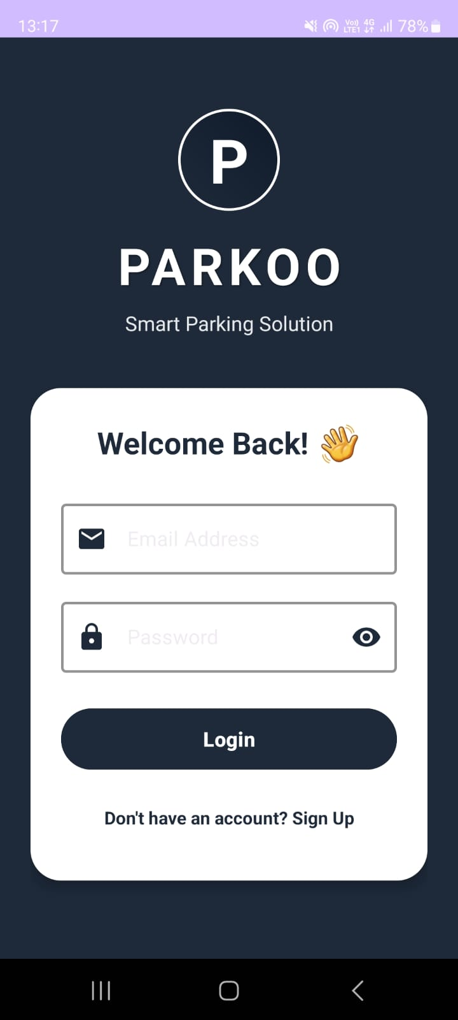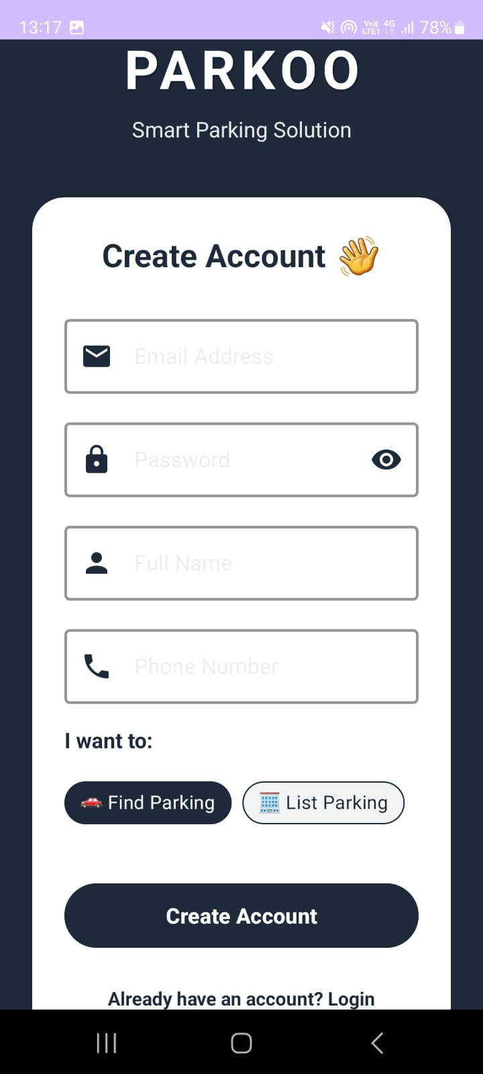
1.1 Login Screen 1.2 Signup Screen

This figure represents the user authentication module of the application. The login screen allows registered users to securely access the system using their credentials, while the signup screen enables new users to create an account. Firebase Authentication is used to manage user identity and security.

Figure 2: User Dashboard and Navigation :-

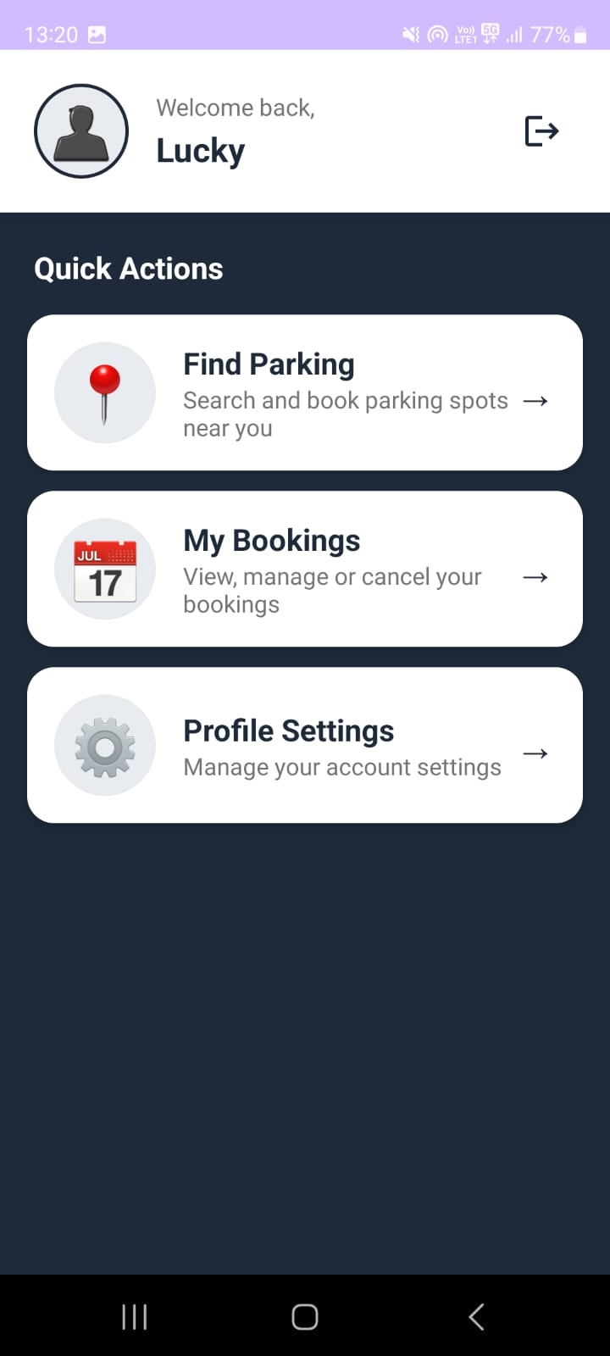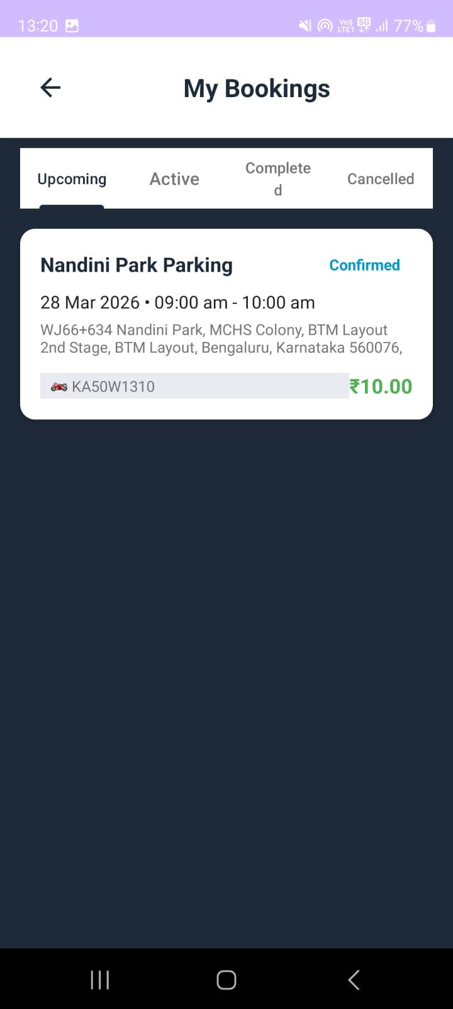
2.1 User Dashboard Screen 2.2 Booking Activity Screen

This figure illustrates the main user interface after login. The user dashboard provides navigation to various features such as parking search and bookings, while the booking activity screen displays the history of reservations made by the user.

Figure 3: Parking Search and Slot Availability:-

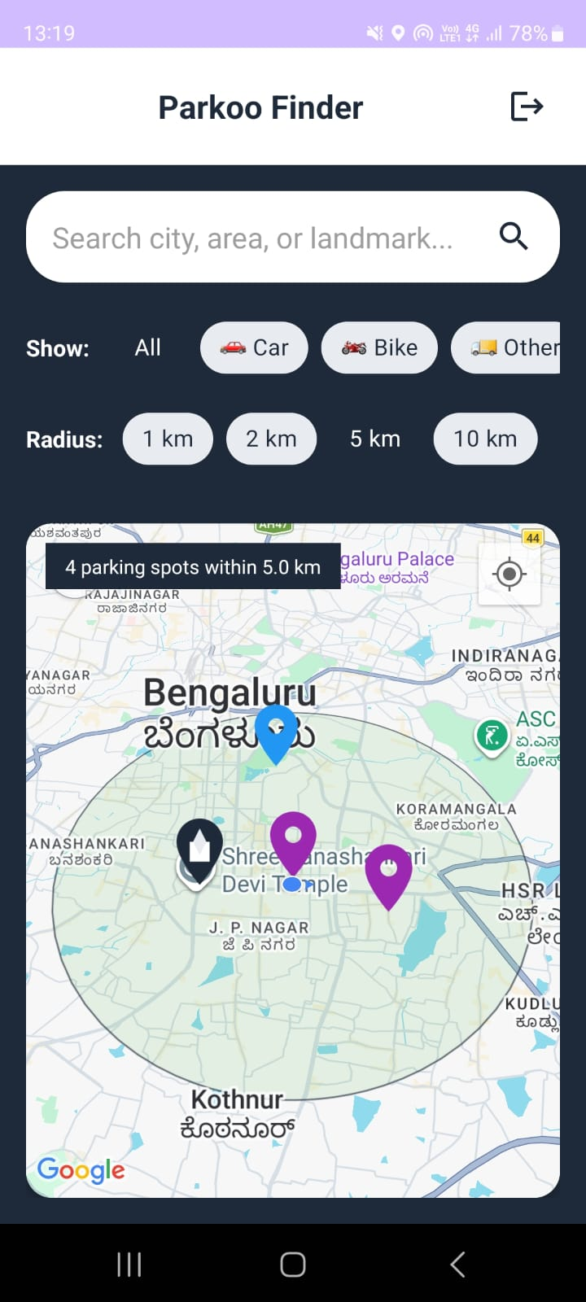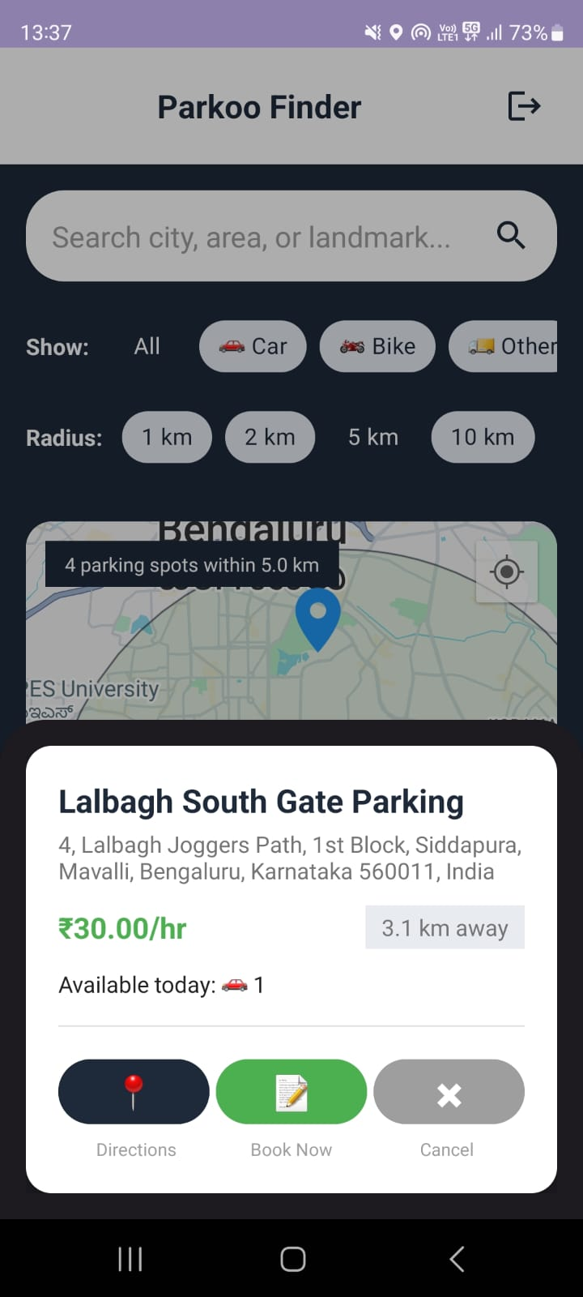
3.1 User Parking Finding Screen 3.2 Slot Details (While Searching)

This figure shows the process of searching for parking spaces. The parking finding screen allows users to explore available parking locations, and the slot details screen provides real-time information about slot availability to assist in decision-making.

Figure 4: Slot Details and Booking Process :-

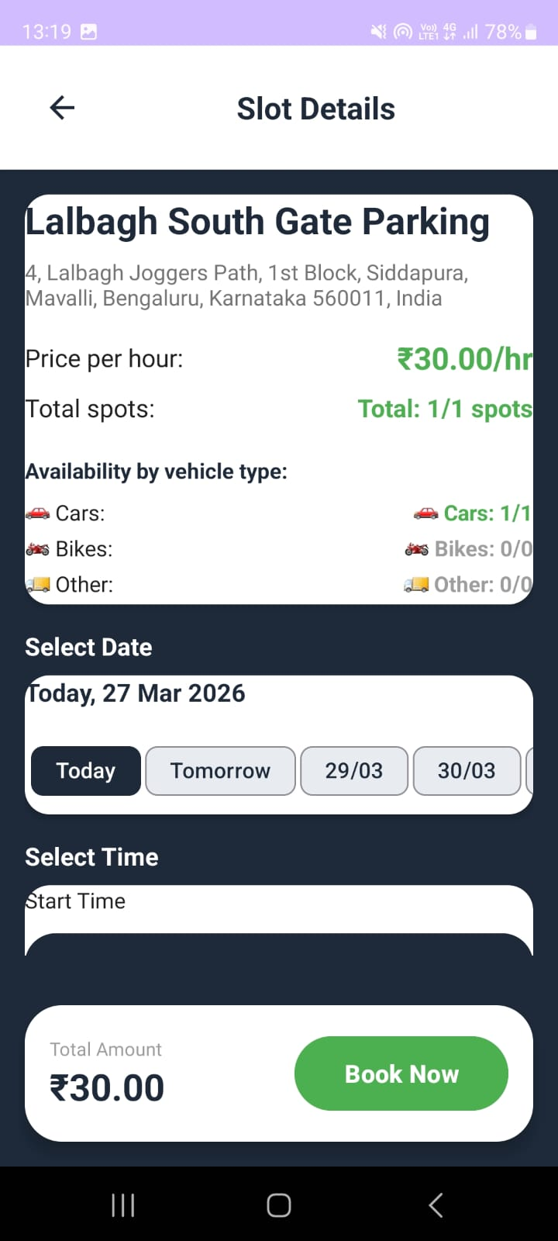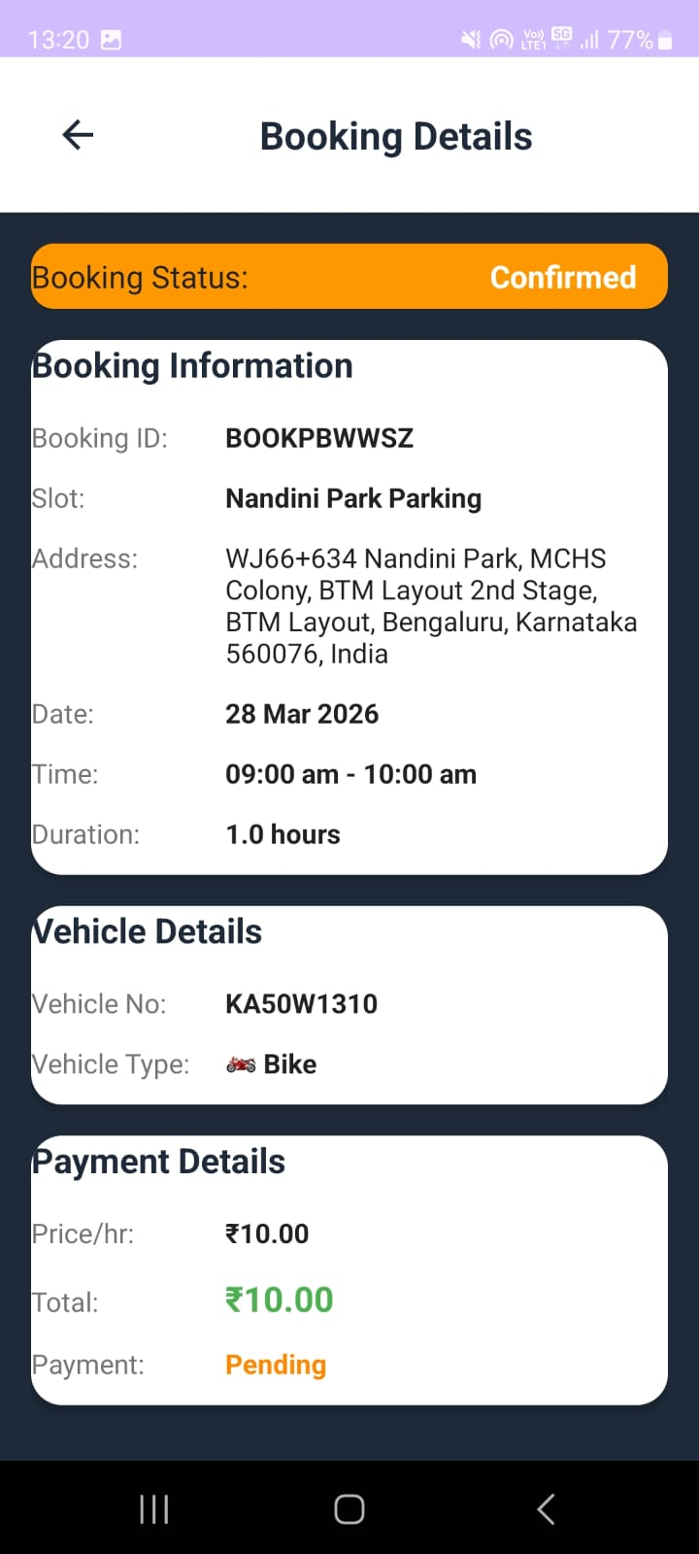
4.1 Slot Details Screen 4.2 Booking Details Screen

This figure demonstrates the slot selection and booking process. The slot details screen displays information about a selected parking slot, and the booking details screen allows users to proceed with reservation by confirming their selection.

Figure 5: Booking Confirmation :-

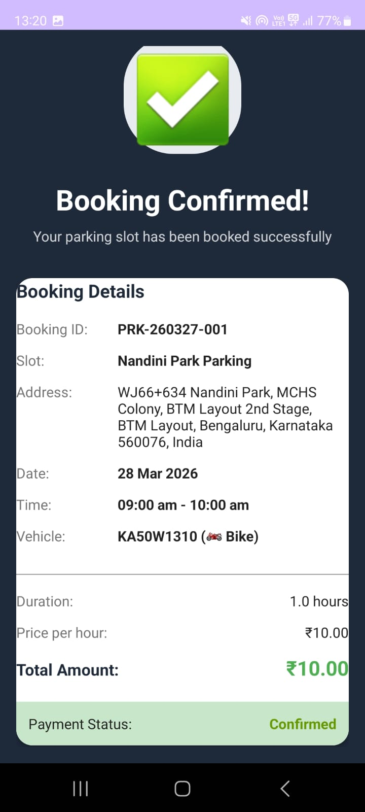
5.1 Booking Confirmation Screen

This figure shows the confirmation interface displayed after a successful booking. It provides immediate feedback to the user, confirming that the parking slot has been reserved.

Figure 6: Admin Parking Management :-

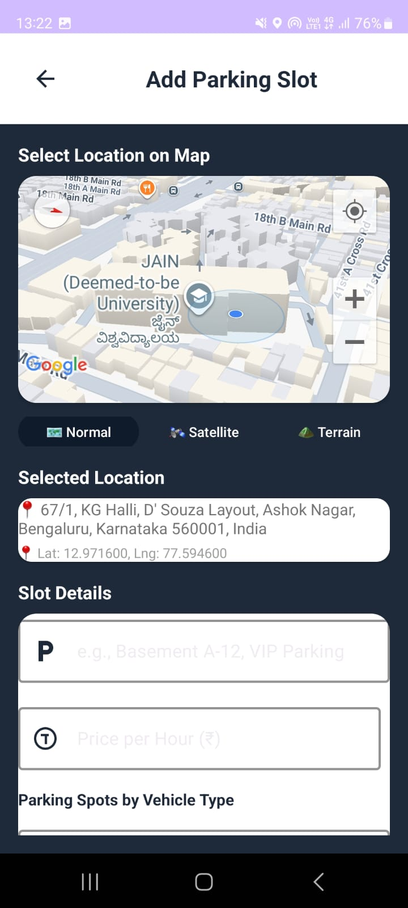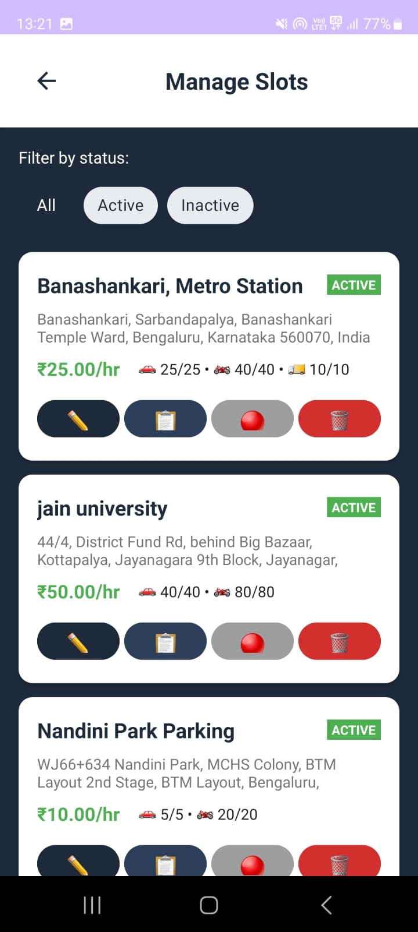
6.1 Add Parking Slot Screen 6.2 Manage Slots Screen

This figure represents the administrative functionality of the system. The add parking slot screen allows administrators to create new parking entries, while the manage slots screen enables monitoring and updating of slot availability.
Figure 7: Owner Dashboard :-

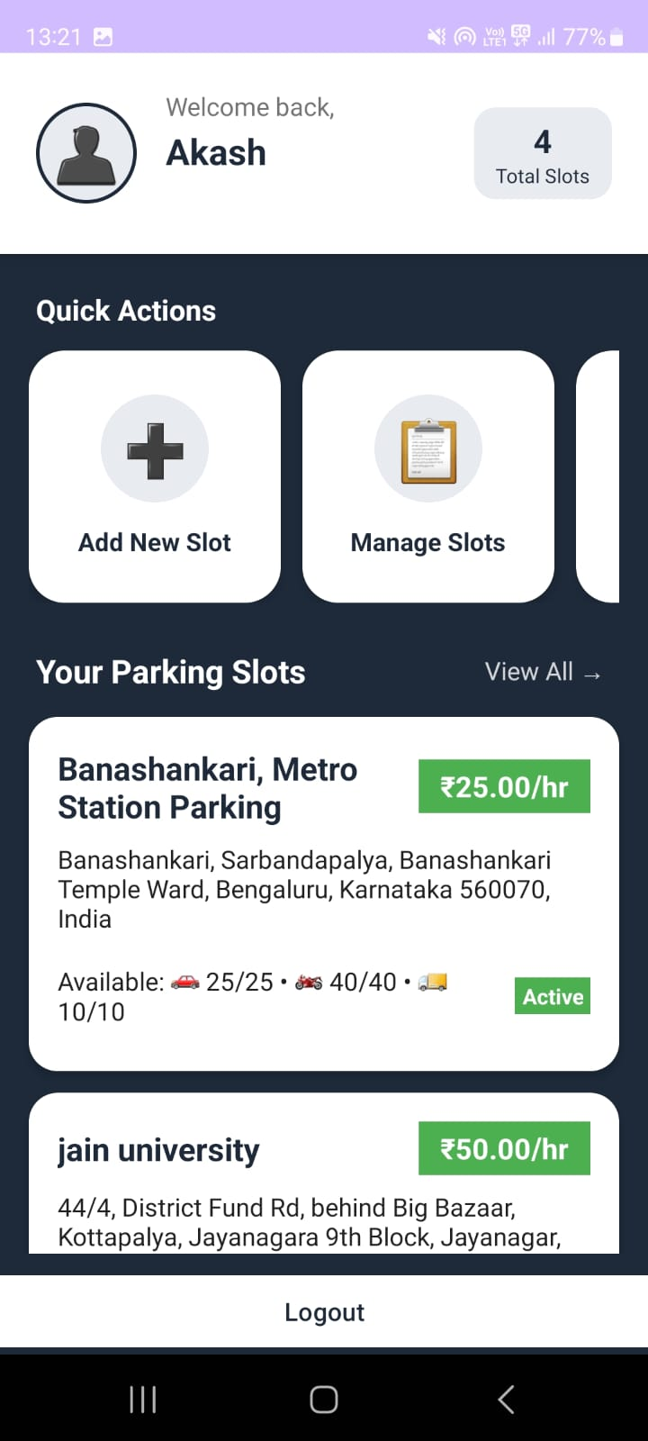
7.1 Owner Dashboard Screen

This figure displays the owner dashboard, which provides an overview of parking management operations, including slot status and administrative controls.

